**4.)** Test the integration of a website or application with other systems or services. This might involve testing how the website or application integrates with third-party services such as payment gateways or social media platforms, and verifying that data is being exchanged correctly.

**Log in functionality**:

Log in the application with the valid credentials.

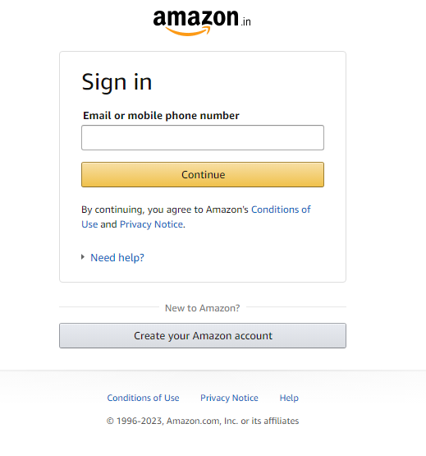

**Search functionality:**

**Entering the key word about the product on search box.**

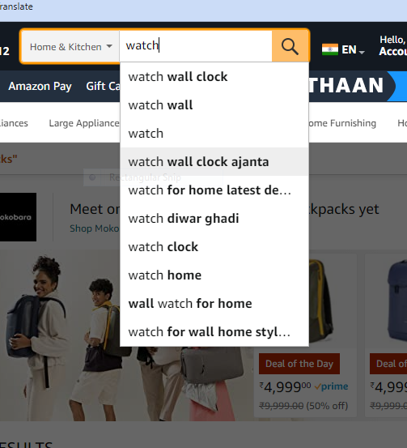

**Selecting the product:**

Selecting the product by clicking the product on search screen

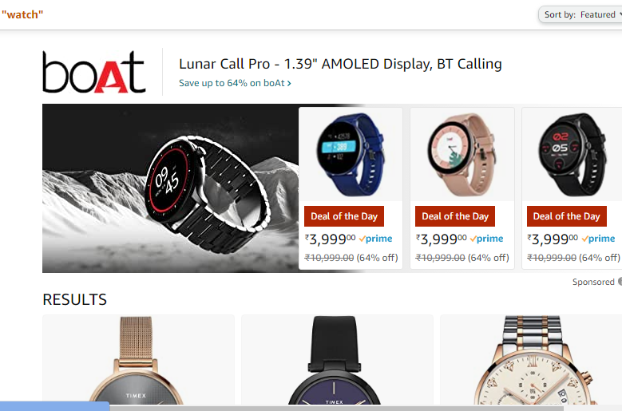

**Add to cart:**

Selecting the product to add cart.

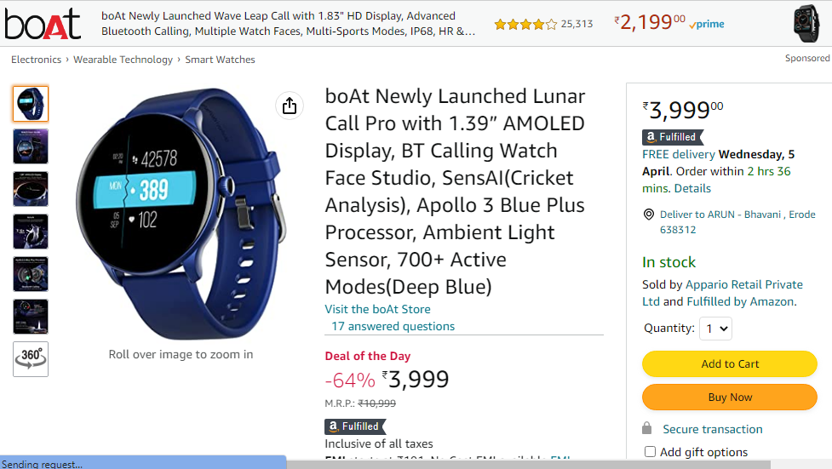

**Proceed payment button:**

Selectingproceed payment button to payment.

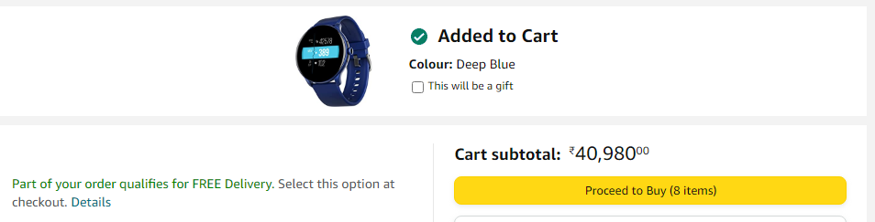

**Entering payment details.**

Selecting and entering payment details of the order**.**

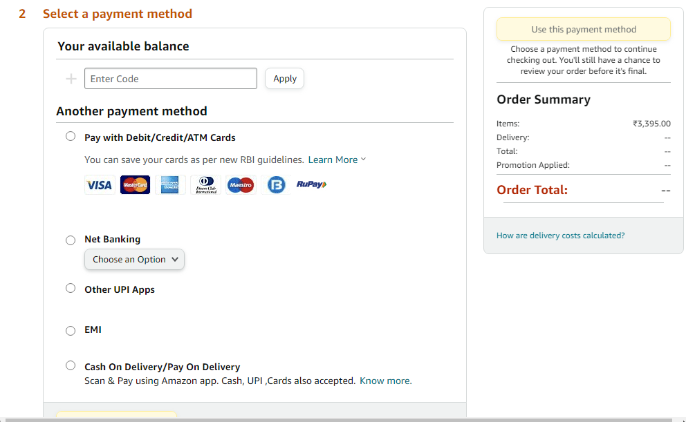

**Payment completion:**

Payment completion by other UPI applications.

